

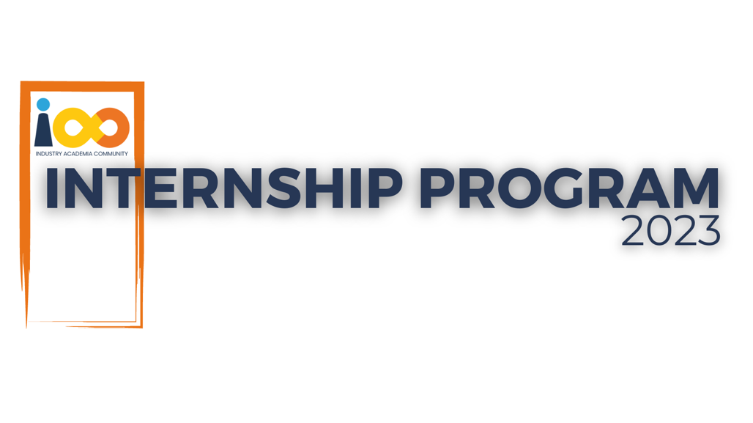

PROJECT REPORT

DATA ANALYTICS  
  
Student Economic Background and Academic Performance Analysis

|  |  |  |  |
| --- | --- | --- | --- |
| **Created By:** | Divya Junghare | **Approved By:** | Suraj Mane |
| **Created On:** | 28/09/2023 | **Approved On:** | 30/09/2023 |

Page left blank intentionally

**INDEX**

**1** **PROJECT DETAILS** 2

**2** **SUMMARY** 2

**3** **INTRODUCTION** 2

3.1 Background 2

3.2 Stakeholders 2

3.3 Objectives 2

**4** **METHODOLOGY** 2

4.1 Considerations & Assumption 3

4.2 Approach 3

4.3 Activities 3

**5** **TARGETTED V/S ACHIEVED OUTPUT** 3

**6** **CONCLUSION** 3

**General Instructions for using the Live Project Report Template**

* This template and the subsequent document created using this template is a confidential document and is the intellectual property of Cloud Counselage Pvt. Ltd. Circulating it outside of the organisation without the consent of Cloud Counselage Pvt. Ltd. is the breach of company policies and will lead to legal actions
* This template is a guideline document to communicate the implementation of design ideas and the results of the work to the stakeholders.
* The **text between inequality (< >) is to be replaced** by relevant text
* Please **remove the yellow highlight on the Text** between the inequality (< >). This is done to help you notice the text to be changed/replaced
* The text in *italics* highlighted in grey is just for reference and should be removed after adding the relevant text

# **PROJECT DETAILS**

|  |  |  |  |
| --- | --- | --- | --- |
| **Project Name** | Student Economic Background and Academic Performance Analysis | | |
| **Project Sponsor** | Tushar Topale | | |
| **Project Manager** | Suraj Mane | | |
| **Start Date** | 01/07/2023 | **Completion Date** | 30/09/2023 |

# **SUMMARY**

The project aims to improve internship success by conducting a comprehensive analysis of student interns. Key goals include increasing resume acceptance rate, correlating academic performance with event participation, aligning career aspirations, gathering feedback from recruiters and interns, optimizing resume preparation time, and monitoring long-term career growth. By achieving these objectives, the project seeks to enhance student prospects, improve matching with internship opportunities, and boost overall student satisfaction and career advancement.

# **INTRODUCTION**

## Background

Resumes are crucial for making a strong first impression when applying for internships or jobs, as recruiters typically spend only 2-3 minutes reviewing each one. Unfortunately, over 70% of resumes get rejected during the initial screening process. This highlights the importance of crafting well-structured and attention-grabbing resumes to increase the chances of being shortlisted for further consideration

## Stakeholders

Harshada Topale

## Objectives

The main objective of this project is to explore and analyse the relationship between students' economic backgrounds, academic performance, competence levels, and their expected salaries upon graduation. By conducting a comprehensive study and data analysis, we aim to gain insights into how socioeconomic factors impact students' educational outcomes and career prospects*.*

# **METHODOLOGY**

These conventions are all about the positions of line breaks, how many characters should go on a line, and everything in between.

## Considerations & Assumption

* Data Accuracy
* Survey Response Representativeness
* Relevance of Events
* Recruiter Feedback Reflects Preferences
* Data Privacy and Consent

## Approach

* Project Planning and Scope Definition
* Data Collection
* Data Analysis
* Feedback Gathering
* Resume Improvement Guidelines
* Career Alignment Recommendations

## Activities Data Collection

* Data Cleaning and Pre-processing
* Exploratory Data Analysis (EDA
* Data Transformation and Feature Engineering
* Data Modelling
* Model Evaluation
* Data Visualization and Interpretation
* Reporting and Presentation

# **TARGETTED V/S ACHIEVED OUTPUT**

The project will deliver a comprehensive data analysis report with insights into the correlation between academic performance, event participation, career aspirations, and internship success. It will include resume improvement guidelines based on recruiter feedback, recommendations for career alignment, and an assessment of the impact of extracurricular events on skill development. Additionally, the project will provide internship conversion analysis, long-term career growth evaluation, student satisfaction survey results, and recruiter feedback summary. These deliverables aim to empower students, improve internship prospects, and contribute to their overall career development.

# **CONCLUSION**

The project scope includes conducting data analysis to study the relationship between academic performance, event participation, career aspirations, and internship success. It also involves developing resume improvement guidelines, assessing the impact of extracurricular events, providing career alignment recommendations, and analysing internship conversion rates and long-term career growth. Additionally, the project includes conducting a student satisfaction survey, summarizing recruiter feedback, creating data visualizations, and preparing a comprehensive presentation for stakeholders. These efforts aim to enhance student internship success and overall career prospects.